ARITHMETIC OPERATORS

1.] ADD(+)

EX:

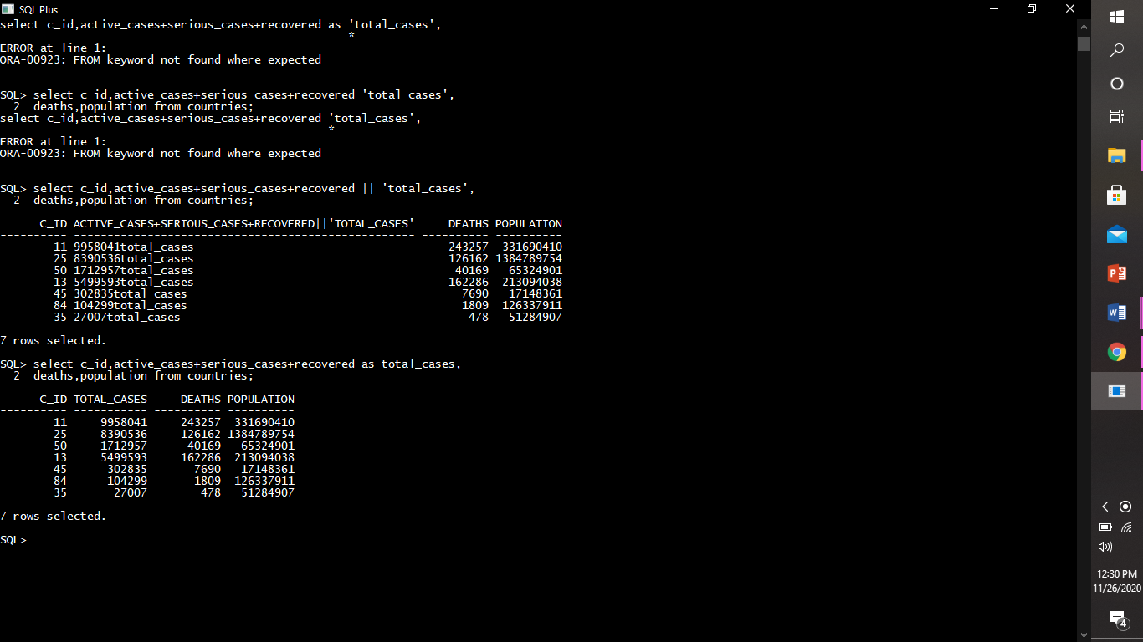

2.] subtract(-)

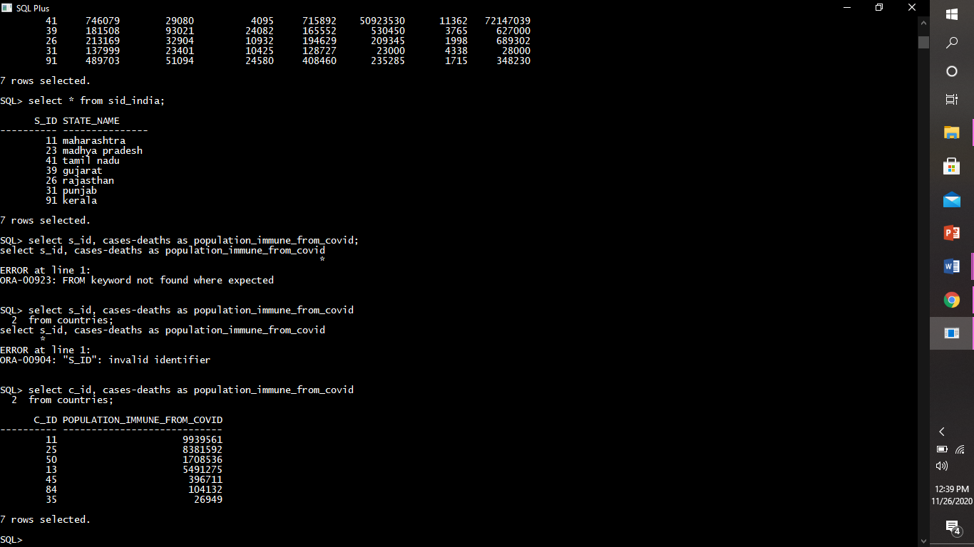

3.]multiplication(*)

4.]division(/)

COMPARISON OPERATORS

1.] equal (=)

Select the info of country having country_id 35.

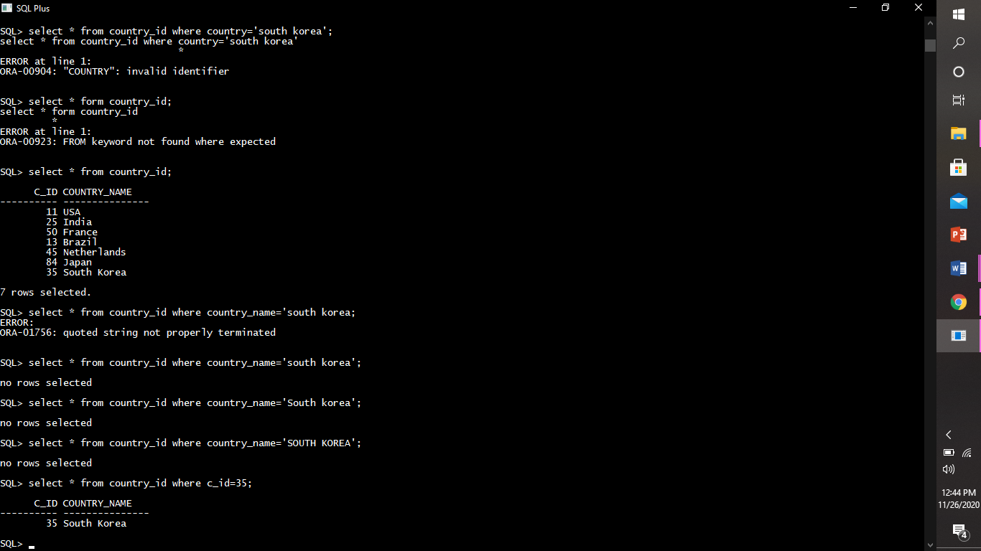

2.]greater than (>)

Display the info of states in usa having covid cases more than 900000.

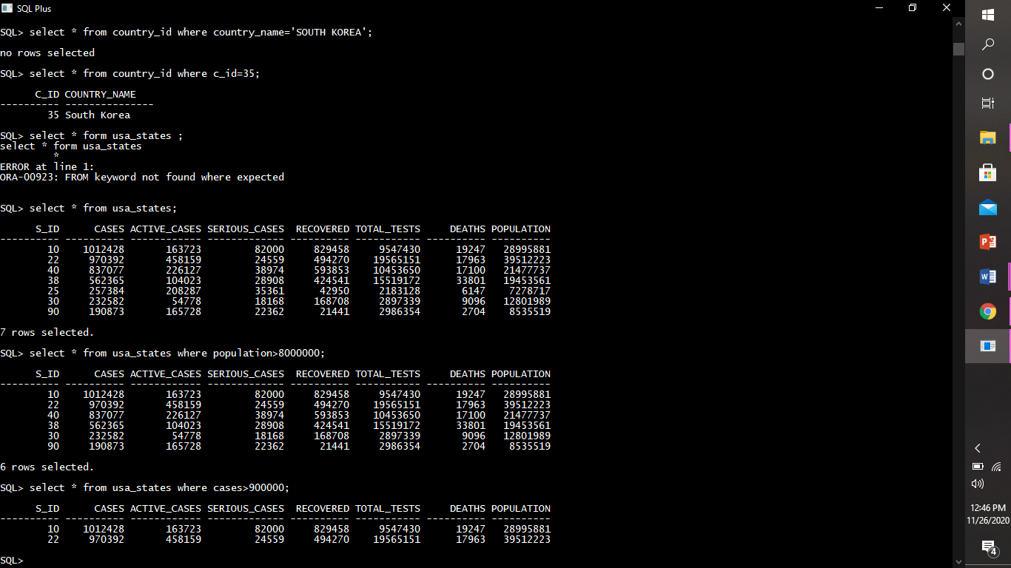

3.] less than (<)

Display info of states in south korea having population greater than 2000000.

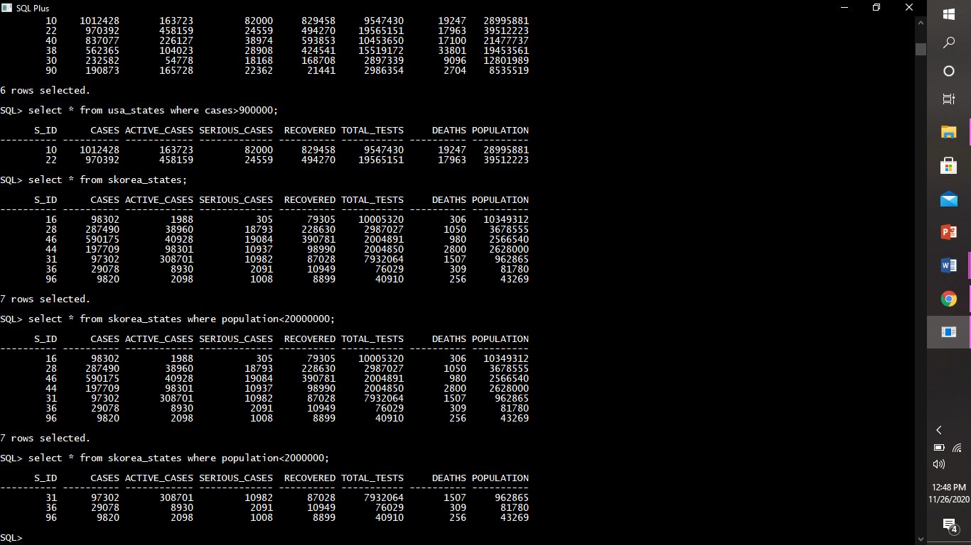

4.] greater than equal to (>=)

Display info of stats in japan having number of deaths greater than or equal to 4890.

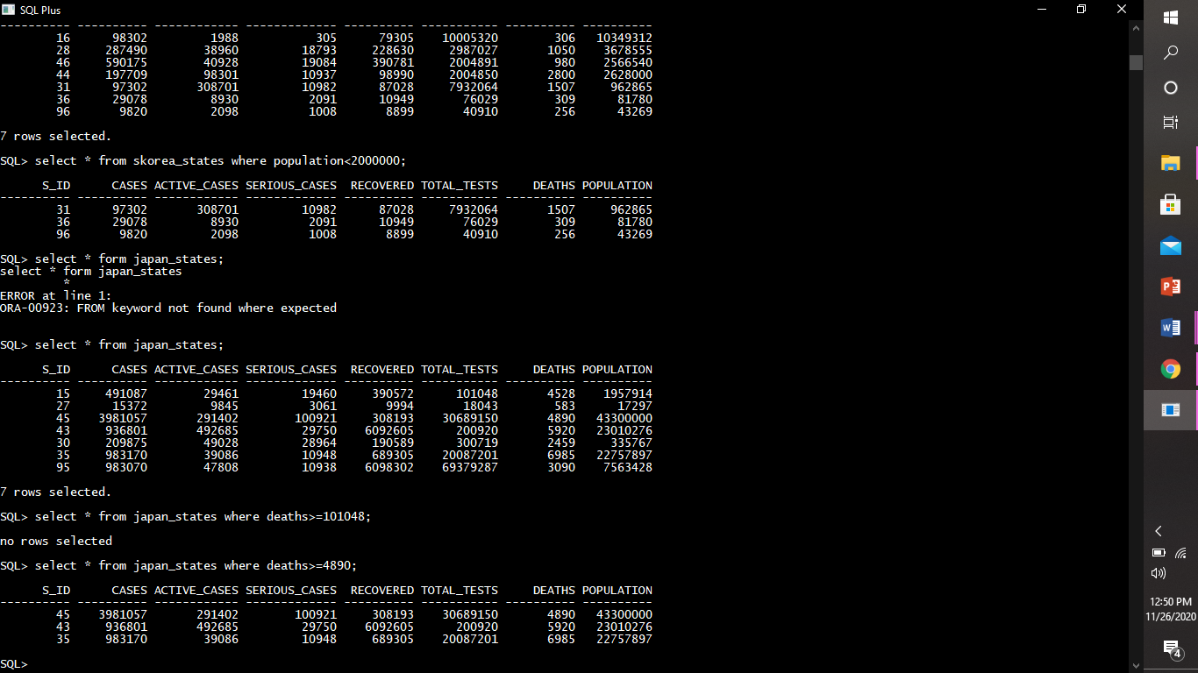

5.] less than equal to (<=)

Display info of states in brazil having total_tests less than or equal to 986870.

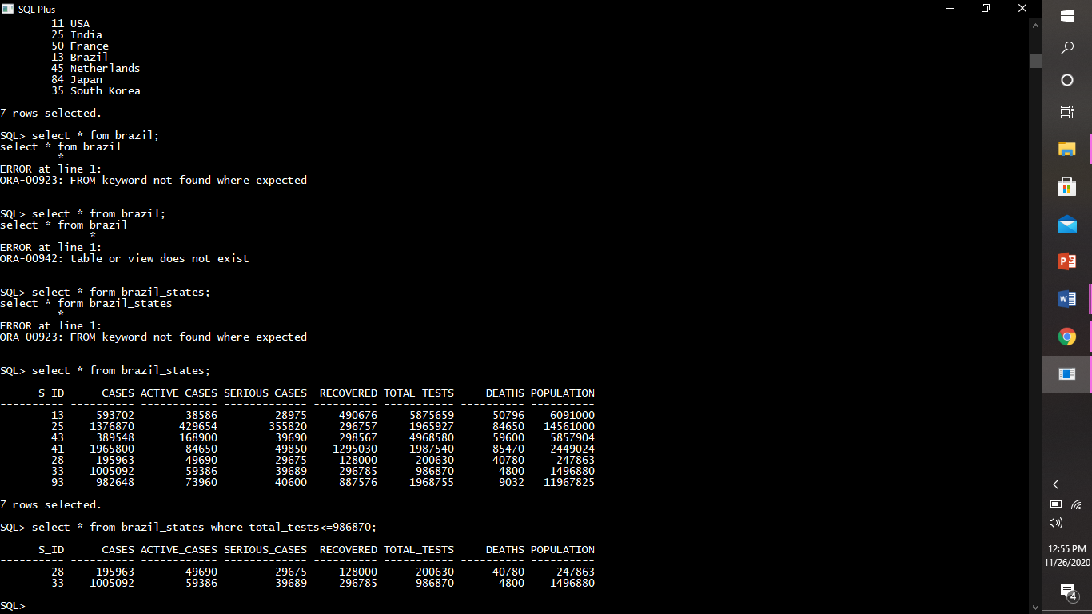

6.] not equal to (<>,!=)

Display info of all korea states except the state having s_id 96.

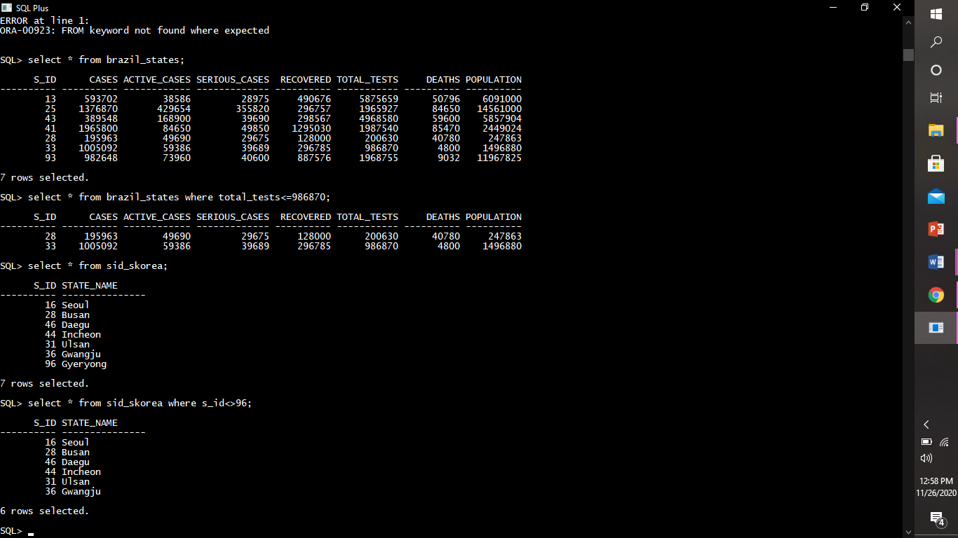

LOGICAL OPERATORS : AND, OR, NOT.

And:

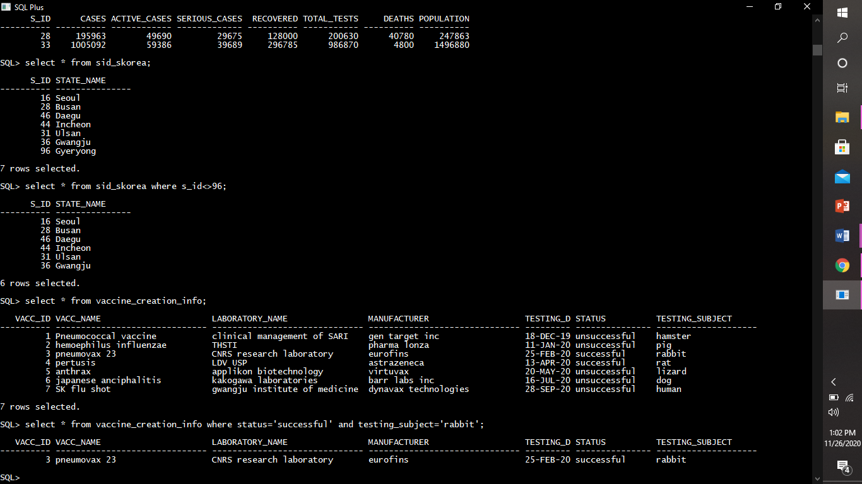

Or:

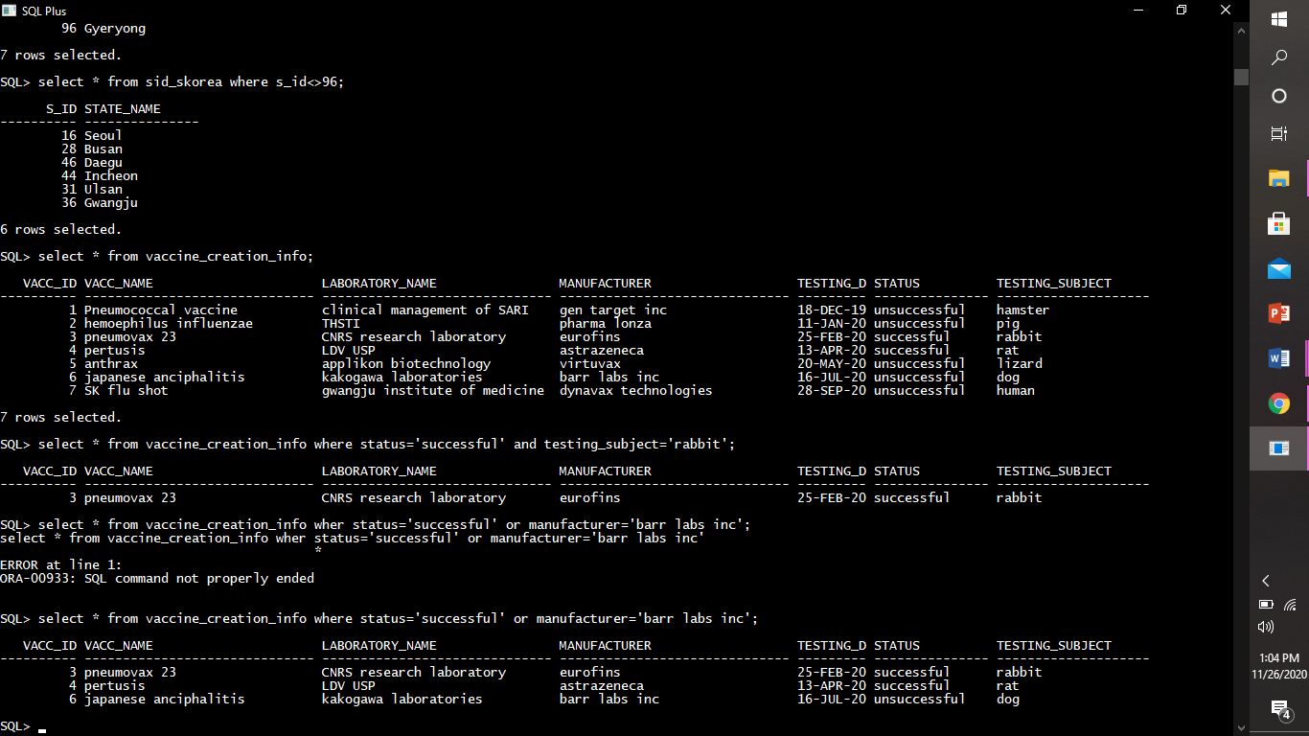

Not

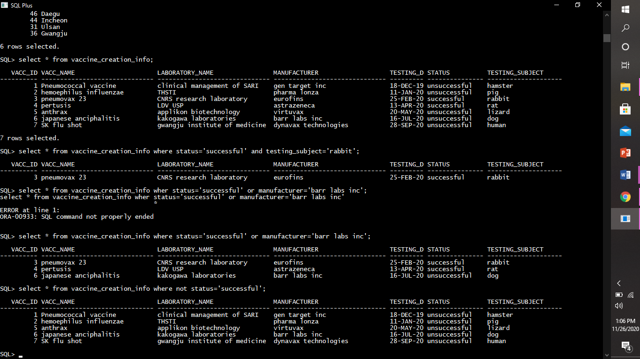

SET OPERATORS: UNION, UNION ALL, INTESCT, MINUS

Union

Displaying info of indian and south Korean states together.

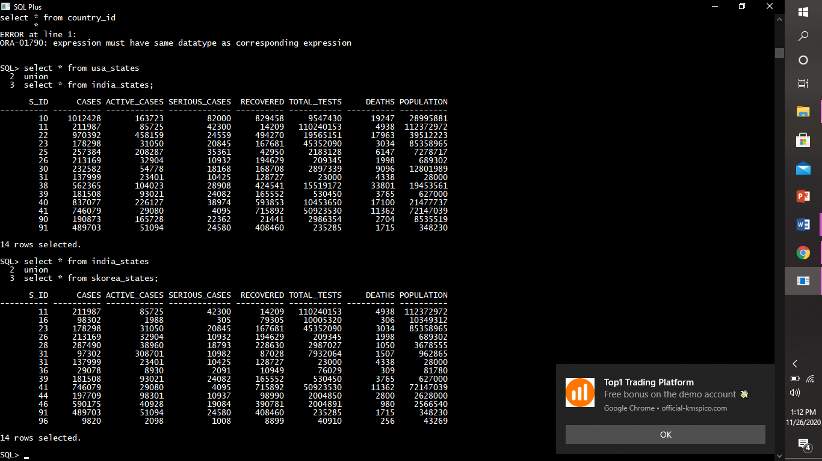

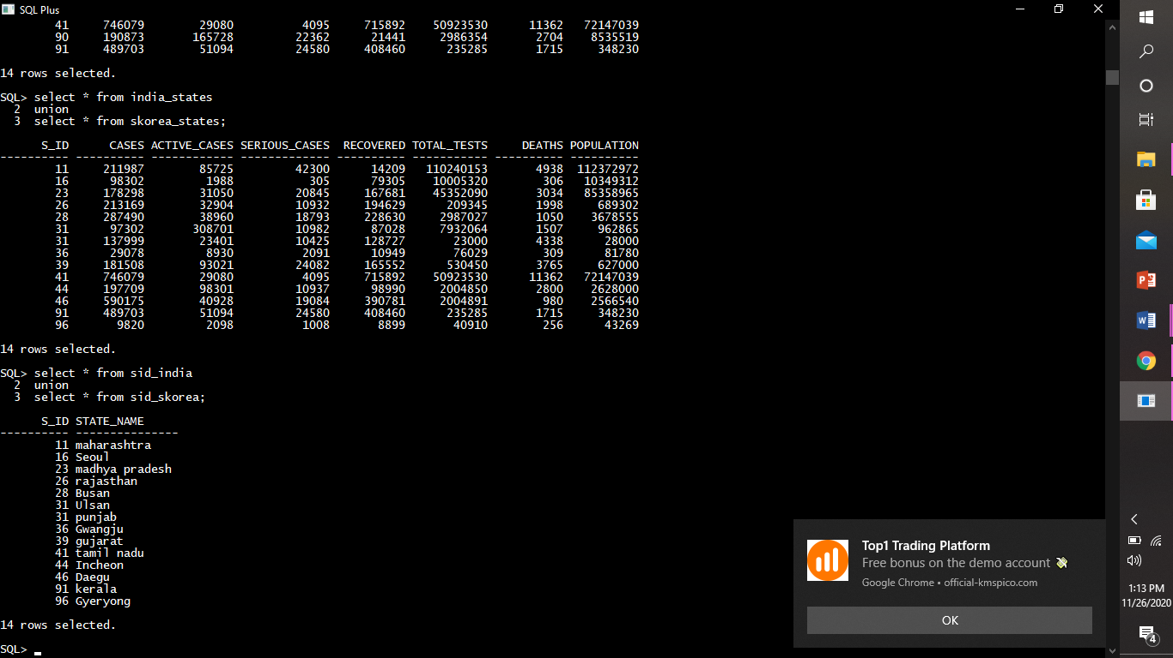

Intersect

Minus

RANGE SEARCHING OPERATORS: BETWEEN, NOT BETWEEN

Between

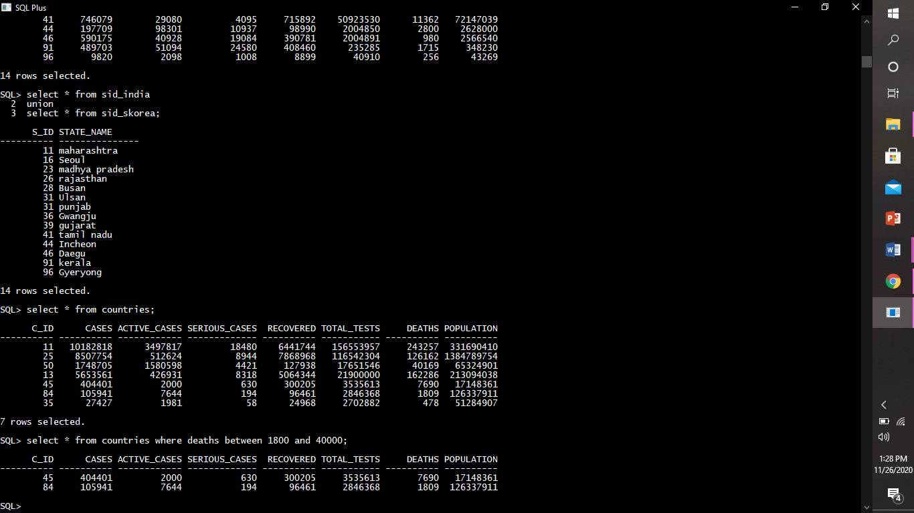

PATTERN MATHCING OPERATORS: LIKE, NOT LIKE

Like

